Alex Ortunio
Employee Absent
Project 4

Input:
1. Total number of employees in company.
2. employee id
3. number of absences from said employee
4. repeat for all of employees
Output:
to console
1. Nothing except prompts for input and programmers name.
To file
1. "EMPLOYEE ABSENCE REPORT" at the top of the file to denote what the file is.
2. top of the table(column headers)
3. line containing employee id in addition to the # of absences
4. Statement containing total employees and total absences.
5. Statement containing the average absences between all employees.
6. Programmers name.
Process/Algorithm:
1. Write the header to file, clearing it as well.
2. Using the numOfEmployee function get the total number of employees(function itself is a prompt:cin with basic input validation).
3. Using the totDaysAbsent function write the table of employee ids and days absent to the file, while also counting the total absences between all the employees.
1. In the totDaysAbsent function, initally open the file in append mode as not to overwrite what has already been written
2. Get employee id and absences and write to file
3. Using a for loop repeat 2 for each employee, while also adding the # of absences to a running total.
4. Return the total absensces.
4. Using the AverageAbsent function calculate the average absences per employee.
5. Output the found data to the text file in a easy to understand way.

screenshot:
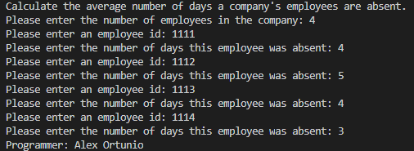

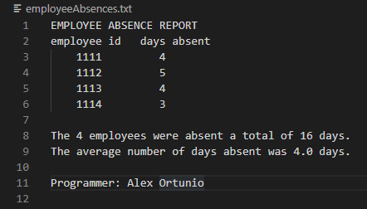

Test Table:
Test Case # | Input | Actual Input | Expected Output | Actual Output | Did the test pass?
1 | No. of employees :  4  Employee ID’s/Days of absence :  1111 4  1112 5  1113 4  1114 3 | 4  1111  4  1112  5  1113  4  1114  3 | Total: 16  Average: 4.0 | Total: 16  Average: 4.0 | Yes
2 | No. of employees :  5  Employee ID’s/Days of absence :  1234 2  2234 4  3234 6  4234 9  234 4 | 5  1234  2  2234  4  3234  6  4234  9  234  4 | Total: 25  Average: 5.0 | Total: 25  Average: 5.0 | Yes
3 | No. of employees :  1  Employee ID’s/Days of absence :  5678 10 | 1  5678  10 | Total: 10  Average: 10.0 | Total: 10  Average: 10.0 | Yes
4 | No. of employees :  7  Employee ID’s/Days of absence :  5432 2  5433 4  5434 6  5435 9  5436 2  5437 3  5438 4 | 7  5432  2  5433  4  5434  6  5435  9  5436  2  5437  3  5438  4 | Total: 30  Average: 4.3 | Total: 30  Average: 4.3 | Yes

Lesson Learned:
I learned how to write to and append files.
Also practiced some better comment edicate.

